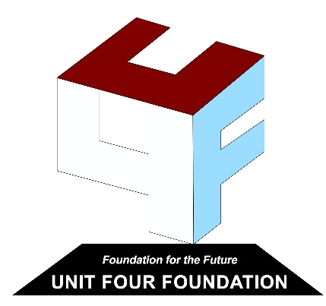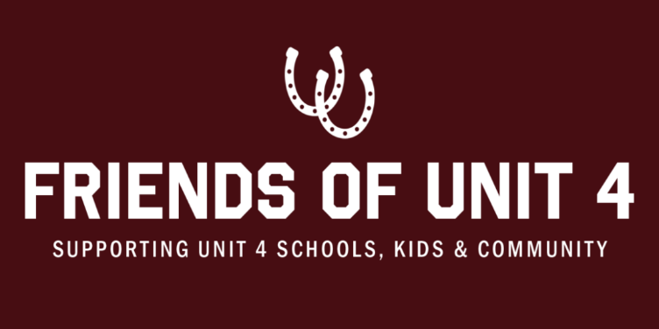

Grant Application

Date:

Contact Person:

Phone/e-mail:

Building:
How many kids will this impact:

How would you best describe the use of these requested funds? Please circle one:
Education Building Improvements Extracurricular Other

Project Description

Briefly describe how this grant would be used. Explain how receipt of these grant funds will benefit students and their overall experience in Community Unit School District #4 and/or enhance learning to better prepare Unit 4 students for the future. What students or staff will benefit and approximately how many will be served?

How will you monitor and/or evaluate this grant?

Total Project Cost:

Please submit completed application(s) via e-mail to UnityGrants@hotmail.com or mail to Unity Grants, PO Box 200, Mendon, IL 62351. A committee, including but not limited to, the Superintendent, Unit 4 Foundation member(s) and Friends of Unit 4 member(s) will review your request and coordinate distribution to the correct entity for discussion. If approved, please send a picture of the grant being used by students to the email above.
All allotted funds must be spent by July 31 following the school year the grant is approved.

